LAB EXPERIMENT RECORD
Set 1: Monthly Sales Data

Department | AI&DS
Course Code / Course Name | DSA0602 / Data Handling and Visualization
Experiment | Data Visualization using R
Name | DEVAMADA HEMASREE
Register Number | 192524114
Date | 29 September 2026
Day | Tuesday

SET 2: CUSTOMER FEEDBACK ANALYSIS
Dataset: Customer Satisfaction
Customer ID | Age | Satisfaction Score
1 | 25 | 4
2 | 30 | 5
3 | 35 | 3
4 | 28 | 4
5 | 40 | 5

PROGRAM 1: Histogram (Customer Age)
Aim: To show the distribution of customer ages.
graphics.off()
graphics.off()
age <- c(25, 30, 35, 28, 40)

hist(age, breaks = seq(20, 40, by = 5),
xlab = "Age", ylab = "Number of Customers",
main = "Distribution of Customer Ages", col = "skyblue")
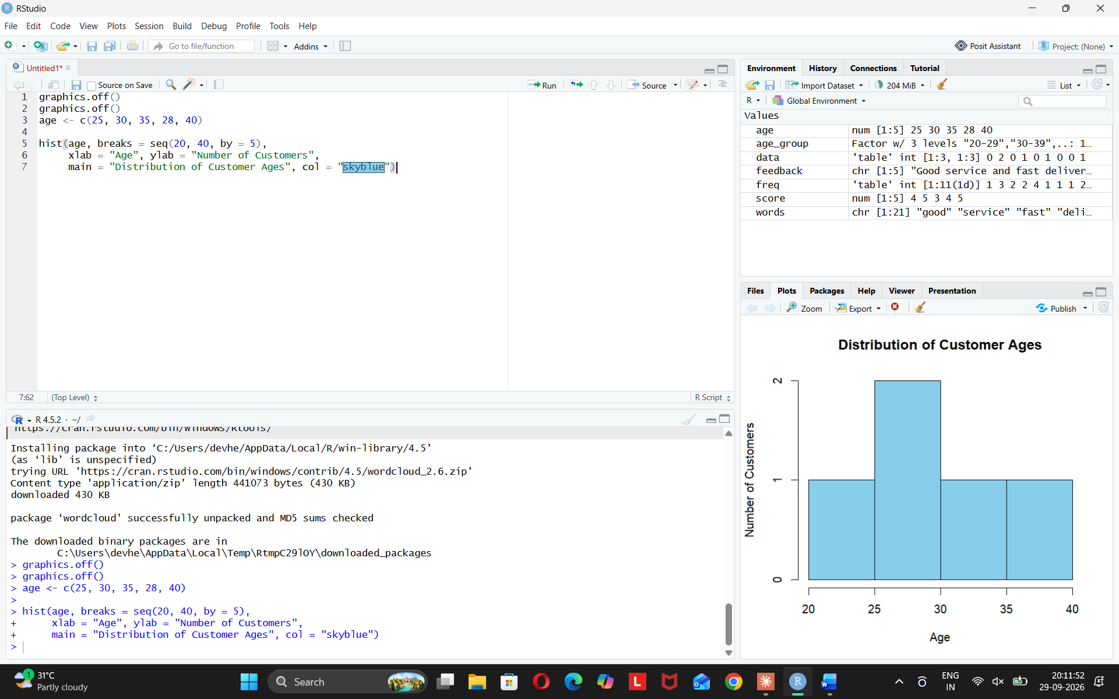
Observation: Most customers are aged 25–30.
PROGRAM 2: Pie Chart (Satisfaction Scores)
Aim: To show the distribution of satisfaction scores.
graphics.off()
score <- c(4, 5, 3, 4, 5)
freq <- as.numeric(table(score))
names(freq) <- c("3", "4", "5")
labels <- paste("Score", names(freq), ":", round(freq / sum(freq) * 100), "%")

pie(freq, labels = labels,
main = "Customer Satisfaction Scores",
col = c("yellow", "lightgreen", "lightblue"))
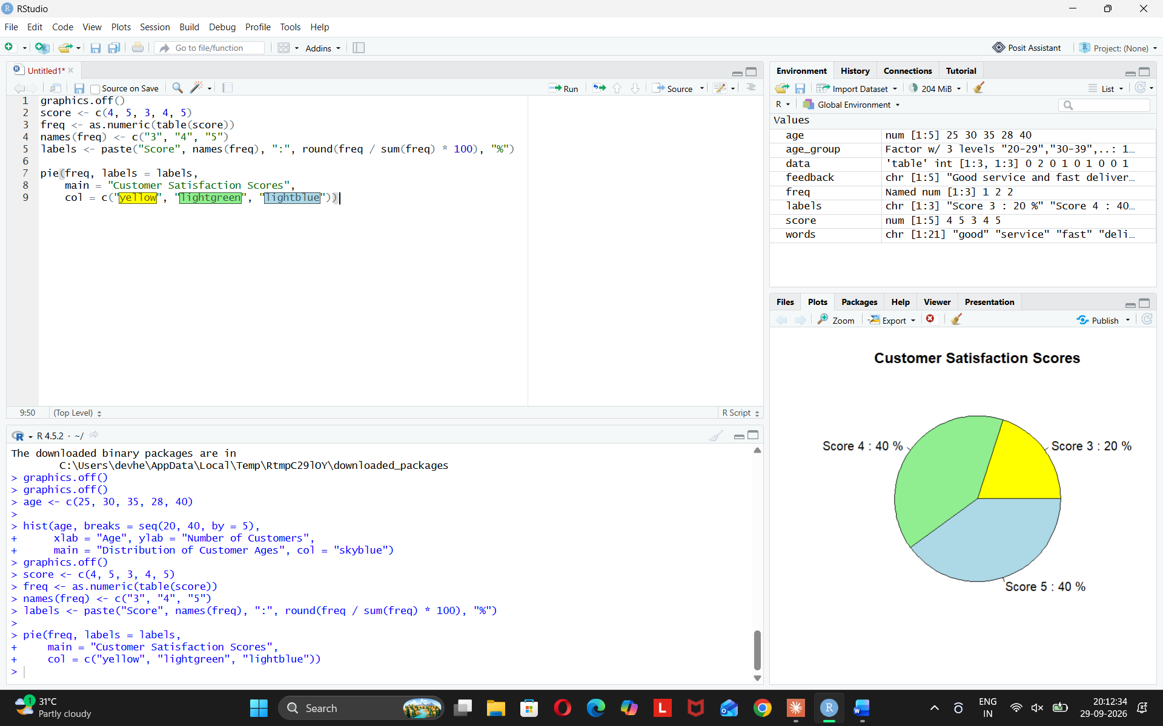
Observation: 80% of customers gave a score of 4 or 5, so satisfaction is high.
PROGRAM 3: Stacked Bar Chart (Satisfaction by Age Group)
Aim: To show satisfaction scores by age group.
age <- c(25, 30, 35, 28, 40)
score <- c(4, 5, 3, 4, 5)

age_group <- cut(age, breaks = c(19, 29, 39, 49),
labels = c("20-29", "30-39", "40-49"))
data <- table(score, age_group)

barplot(data, beside = FALSE,
xlab = "Age Group", ylab = "Number of Customers",
main = "Satisfaction Score by Age Group",
col = c("red", "orange", "green"),
legend.text = rownames(data),
args.legend = list(title = "Score"))
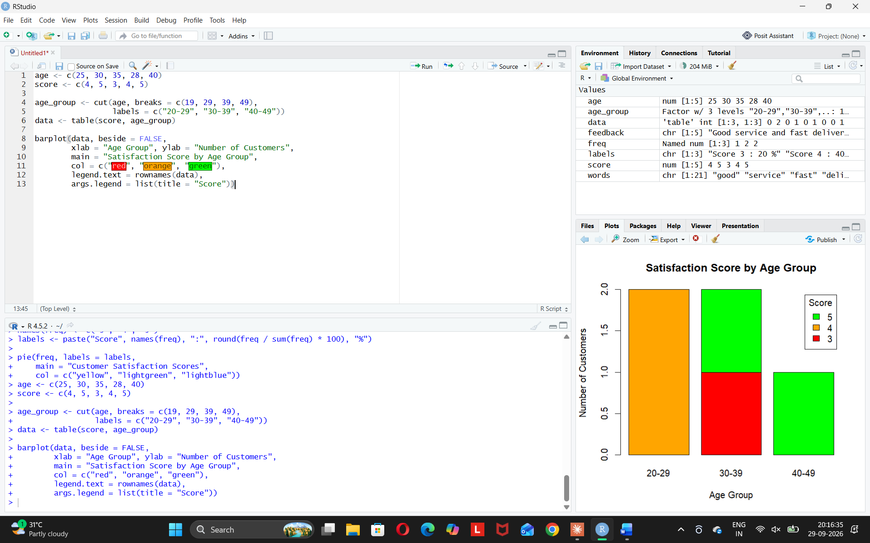
Observation: Older customers are more satisfied.
PROGRAM 4: Word Cloud (Customer Feedback)
Aim: To find common customer sentiments using a word cloud.
install.packages("wordcloud") # run only once
library(wordcloud)

feedback <- c("Good service and fast delivery",
"Excellent support and good quality",
"Average delivery but good price",
"Great quality and excellent service",
"Happy with fast delivery and good service")

words <- unlist(strsplit(tolower(feedback), " "))
words <- words[!words %in% c("and", "but", "with")]
freq <- table(words)

wordcloud(names(freq), as.numeric(freq),
min.freq = 1, colors = rainbow(5))
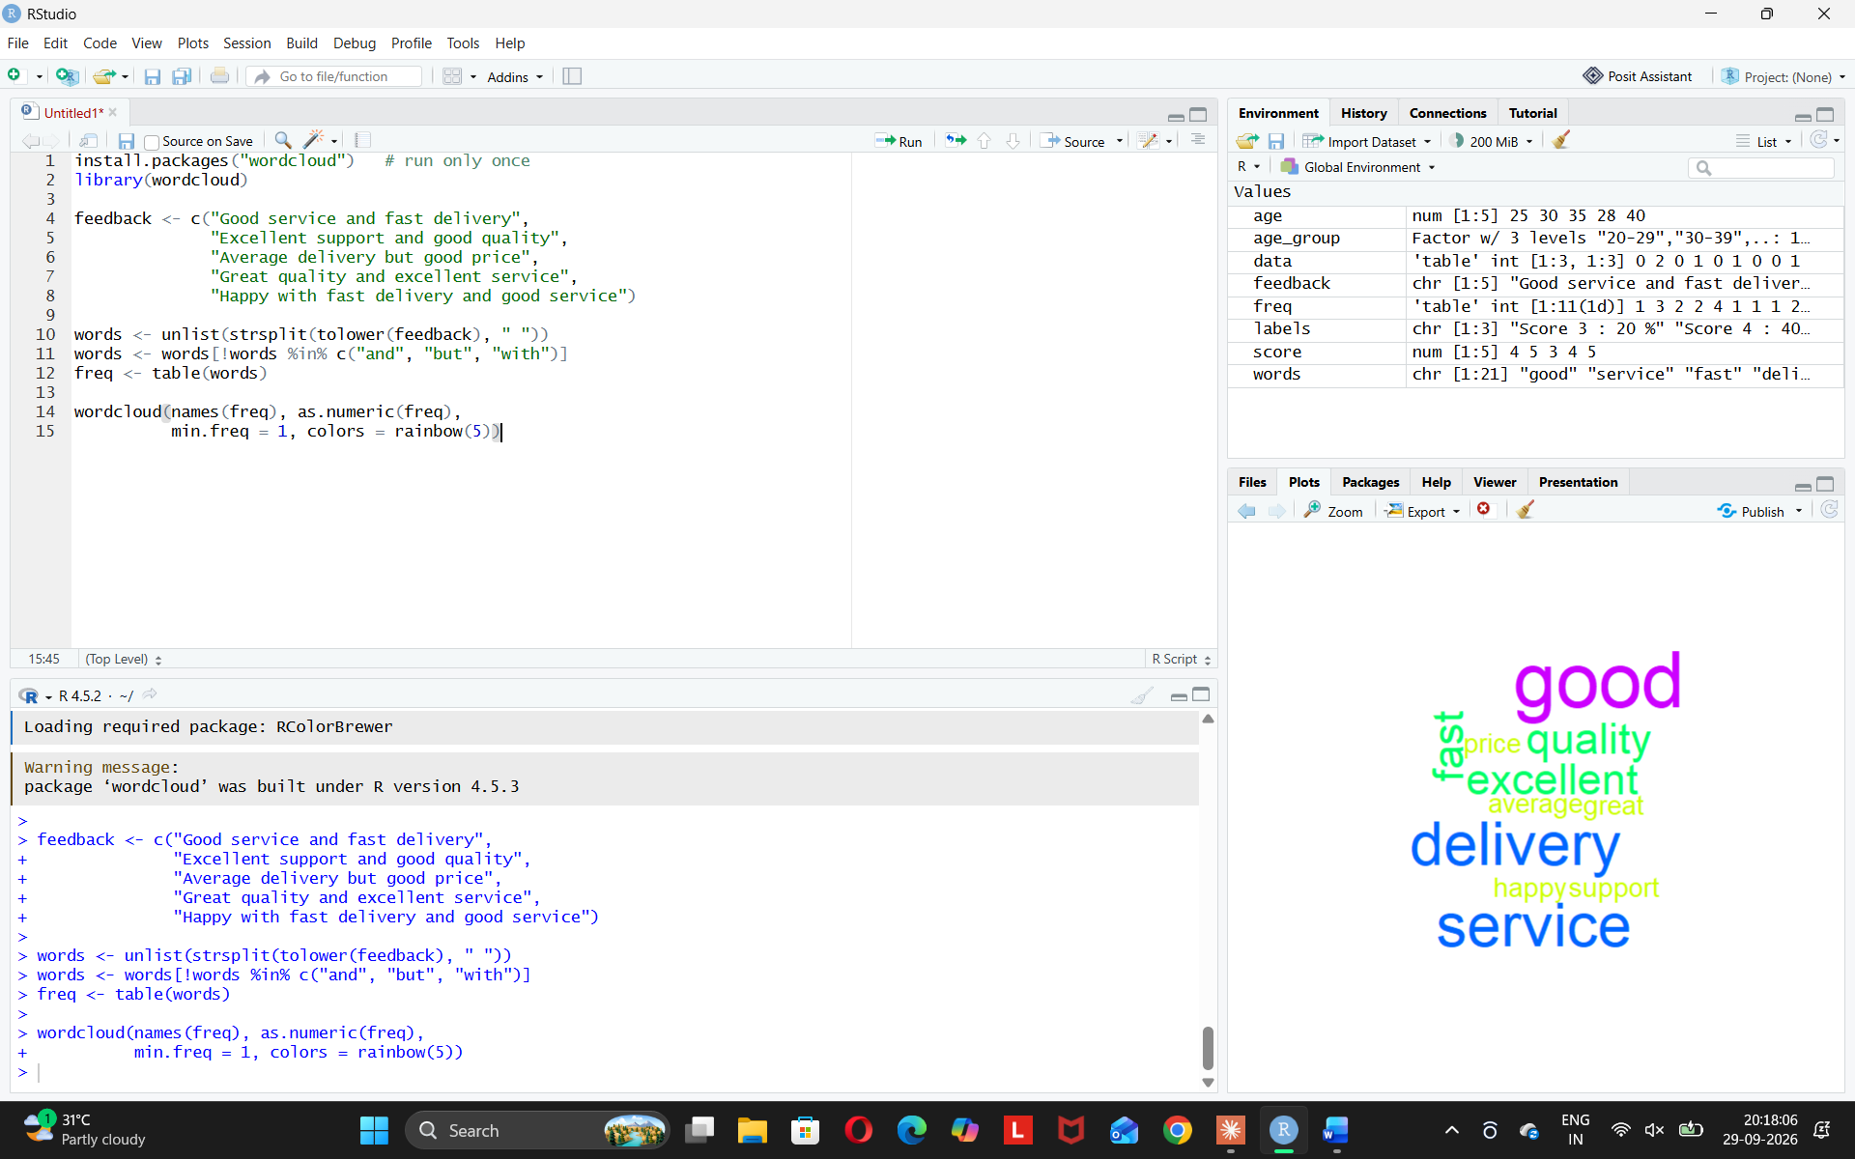
Observation: Customers mostly talk about good service, delivery, and quality, so sentiment is positive.

